LAB # 3
Introduction to Concurrency
OBJECTIVE
Understanding and implementing the concept of concurrency through different mechanisms of
Lab Task:
- Implement the following program on eclipse IDE and answer the following questions:
- How many threads are running?
- How many tasks are running?
- If more tasks are added than what will be the impact on number of threads?
- Explain the flow of program:
CODE:
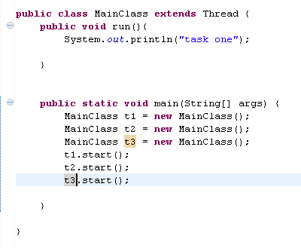

OUTPUT:
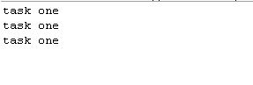

The program creates 3 threads (t1, t2, t3).
Each thread runs the run() method and prints “task one.”
1. How many threads are running?
Ans. 3 threads
2. How many tasks are running?
Ans. 3 tasks (each thread runs one task)
- If more tasks are added?
Ans. More threads will be created.
4. Flow of program:
Ans. main() creates 3 threads , each thread starts →,each prints “task one.”

- With the help of threading print two tables concurrently, print one table number of student roll number e.g. 2019-SE-092 and second number should be date of birth e.g. 05-April.

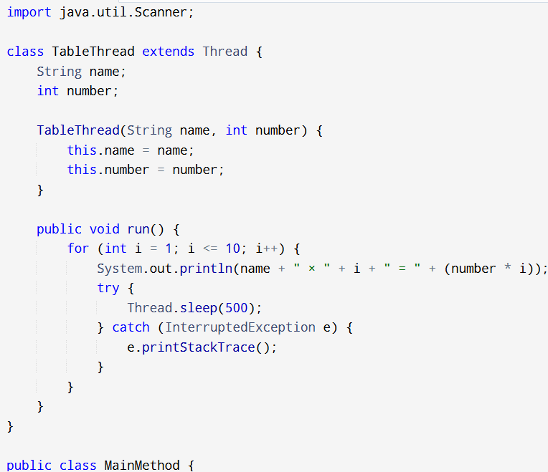
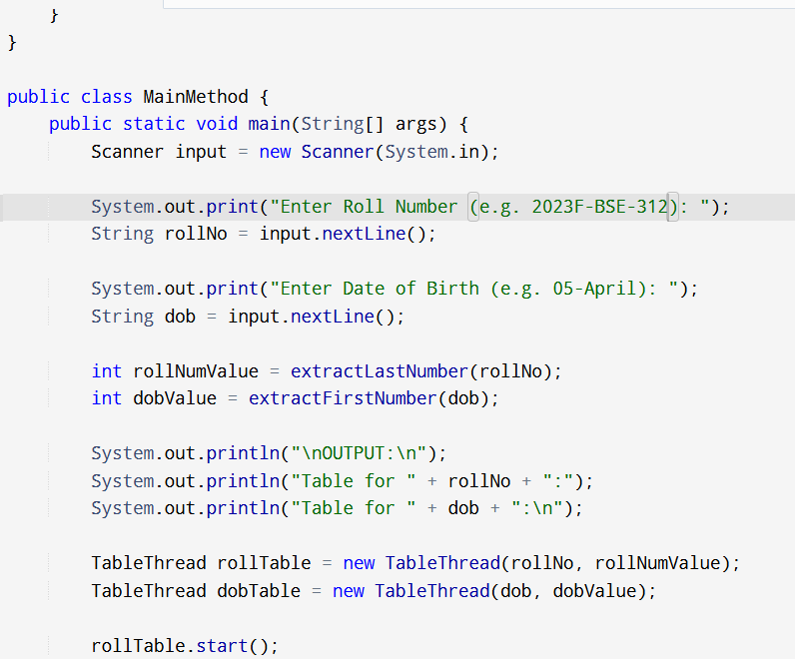

OUTPUT:
